**Database Technologies**

**UE19CS344**

**6th Semester, Academic Year 2021-22**

Week #8: Multi-table joins

(A4) Date: 15/3/2022

|  |  |  |
| --- | --- | --- |
| Name :  SUMUKH RAJU BHAT | SRN :  PES1UG19CS519 | Section :  H |

About the tables involved in join:

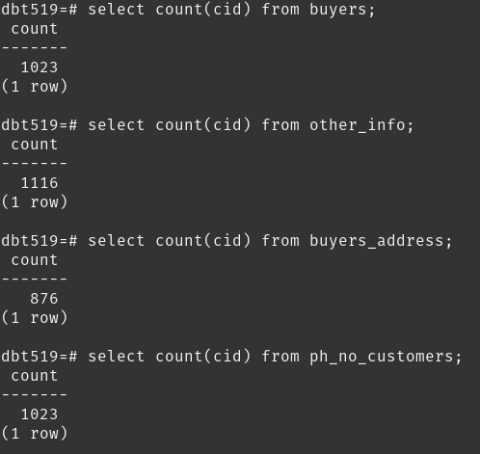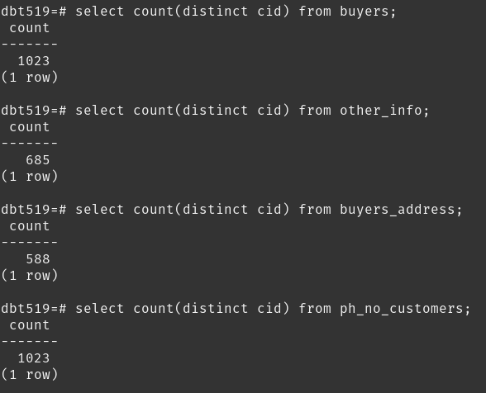

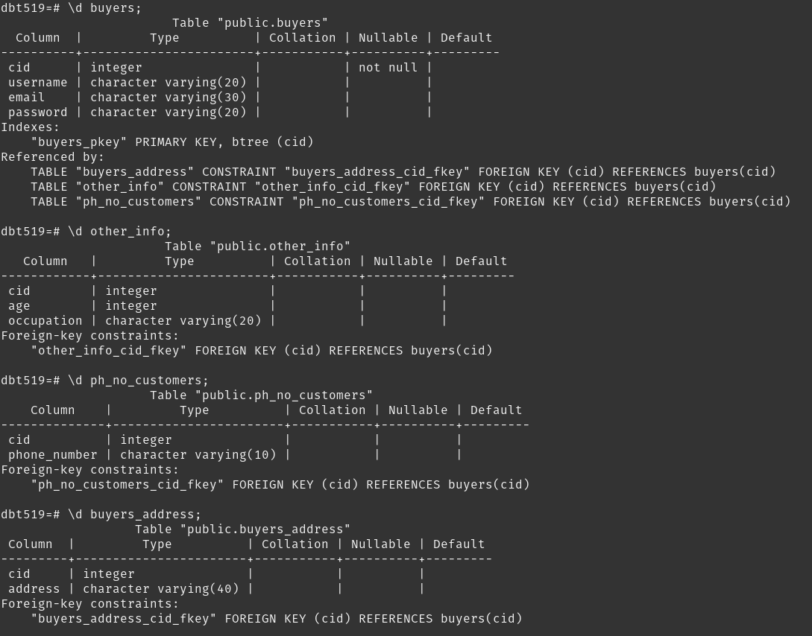

Summary: 4 tables => 4! permutations => 24 permutations

1,2,3,4 indicates the position of table in multi-table join query. Eg: buyers = 2, other_info = 4, buyers_addresses = 1, ph_no_customers = 3 indicates the query:

select * from

*buyers_address* natural join *buyers* natural join *ph_no_customers* natural join *other_info*;

|  |  |  |  |  |  |  |
| --- | --- | --- | --- | --- | --- | --- |
| # | buyers | other_info | buyers_address | ph_no_customers |  | Execution Speed(ms) |
| 1 | 1 | 2 | 3 | 4 |  | 12.192 |
| 2 | 1 | 2 | 4 | 3 |  | 11.517 |
| 3 | 1 | 3 | 2 | 4 |  | 11.55 |
| 4 | 1 | 3 | 4 | 2 |  | 12.484 |
| 5 | 1 | 4 | 2 | 3 |  | 12.275 |
| 6 | 1 | 4 | 3 | 2 |  | 12.275 |
| 7 | 2 | 1 | 3 | 4 |  | 12.668 |
| 8 | 2 | 1 | 4 | 3 |  | 13 |
| 9 | 2 | 3 | 1 | 4 |  | 11.707 |
| 10 | 2 | 3 | 4 | 1 |  | 11.985 |
| 11 | 2 | 4 | 1 | 3 |  | 12.509 |
| 12 | 2 | 4 | 3 | 1 |  | 12.417 |
| 13 | 3 | 1 | 2 | 4 |  | 12.237 |
| 14 | 3 | 1 | 4 | 2 |  | 13.138 |
| 15 | 3 | 2 | 1 | 4 |  | 11.451 |
| 16 | 3 | 2 | 4 | 1 |  | 12.372 |
| 17 | 3 | 4 | 1 | 2 |  | 12.332 |
| 18 | 3 | 4 | 2 | 1 |  | 12.418 |
| 19 | 4 | 1 | 2 | 3 |  | 13.648 |
| 20 | 4 | 1 | 3 | 2 |  | 13.058 |
| 21 | 4 | 2 | 1 | 3 |  | 12.824 |
| 22 | 4 | 2 | 3 | 1 |  | 11.015 |
| 23 | 4 | 3 | 1 | 2 |  | 11.593 |
| 24 | 4 | 3 | 2 | 1 |  | 11.351 |

Screenshots:

1. explain analyze select * from buyers natural join other_info natural join buyers_address natural join ph_no_customers;

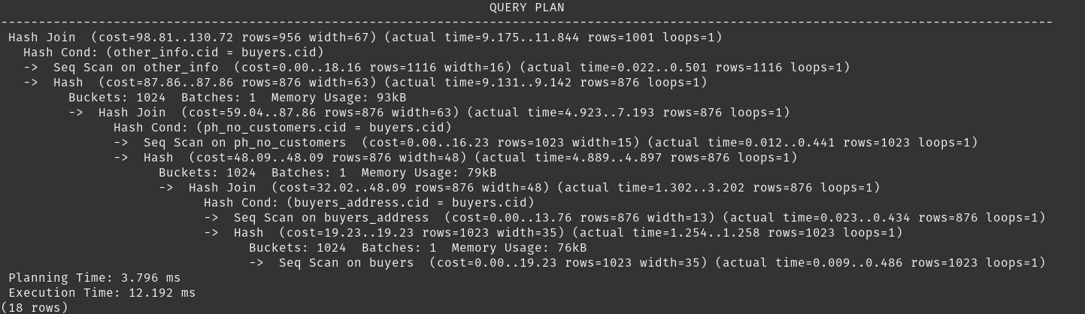

2. explain analyze select * from buyers natural join other_info natural join ph_no_customers natural join buyers_address;

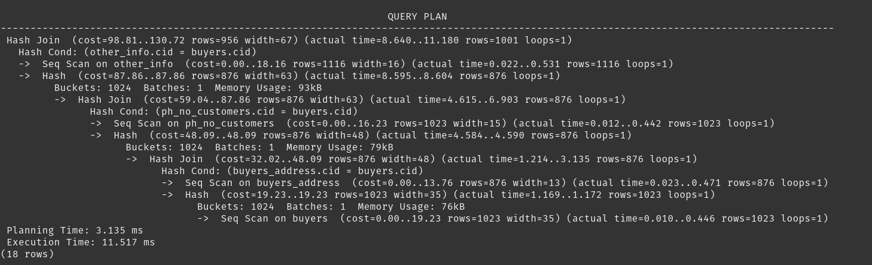

3. explain analyze select * from buyers natural join buyers_address natural join other_info natural join ph_no_customers;

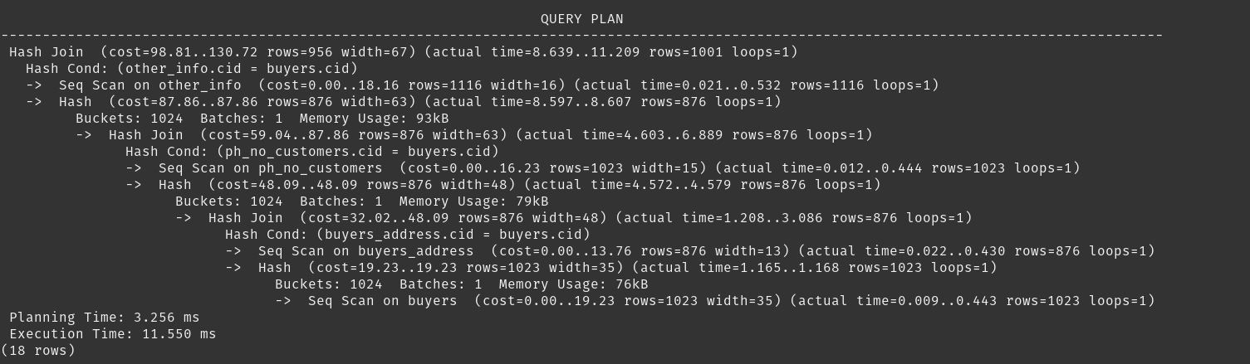

4. explain analyze select * from buyers natural join buyers_address natural join ph_no_customers natural join other_info;

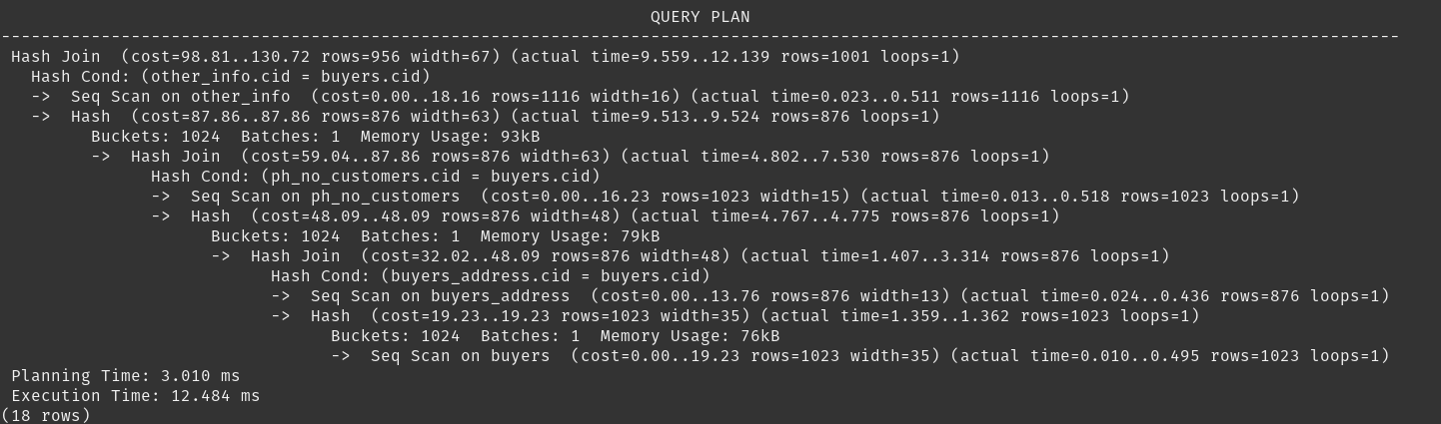

5. explain analyze select * from buyers natural join ph_no_customers natural join other_info natural join buyers_address;

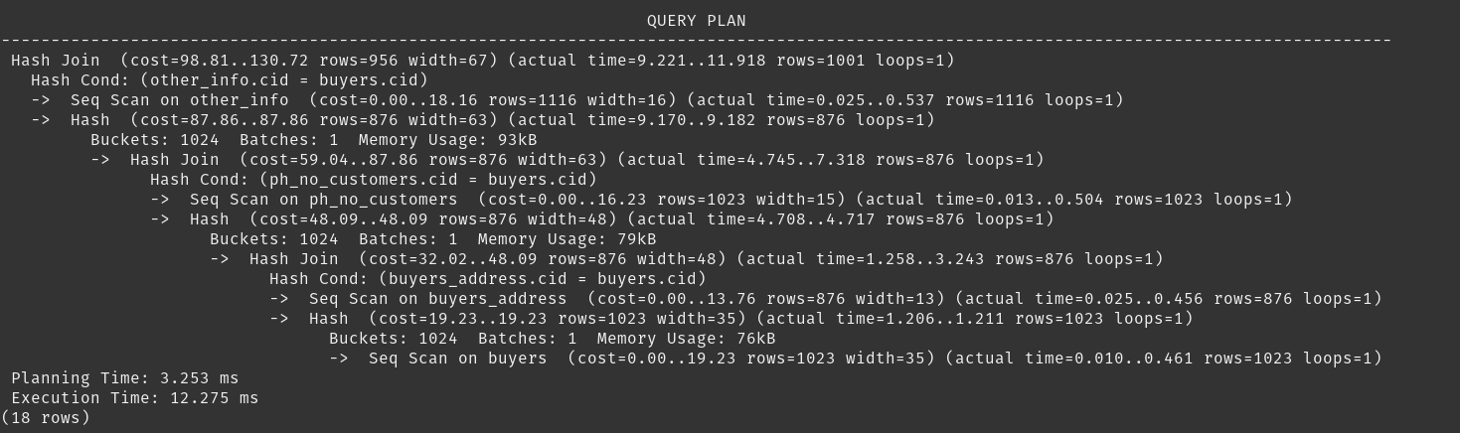

6. explain analyze select * from buyers natural join ph_no_customers natural join buyers_address natural join other_info;

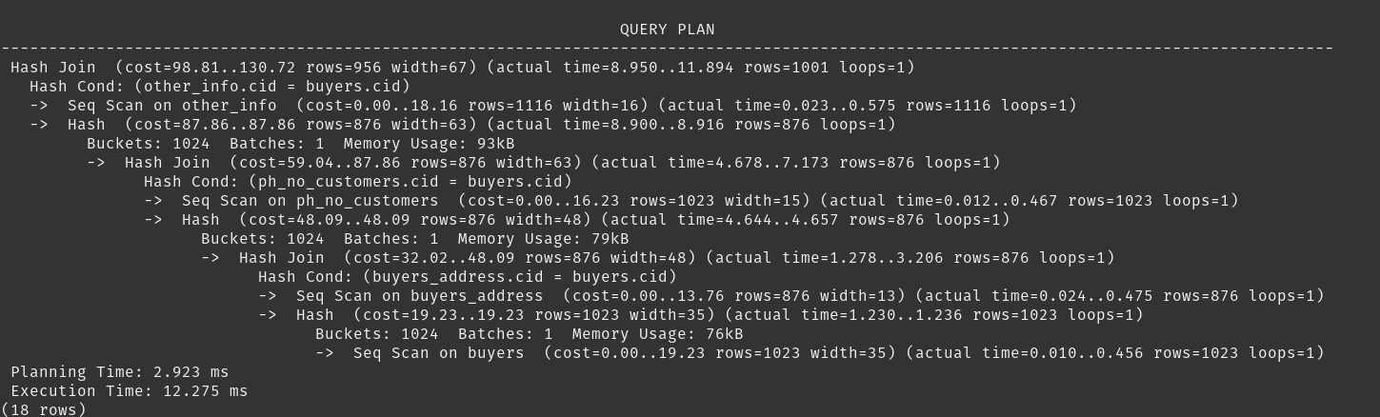

7. explain analyze select * from other_info natural join buyers natural join buyers_address natural join ph_no_customers;

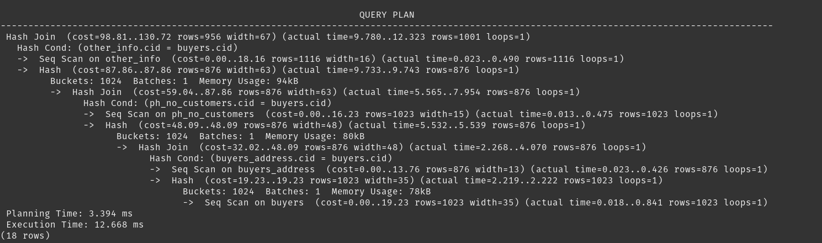

8. explain analyze select * from other_info natural join buyers natural join ph_no_customers natural join buyers_address;

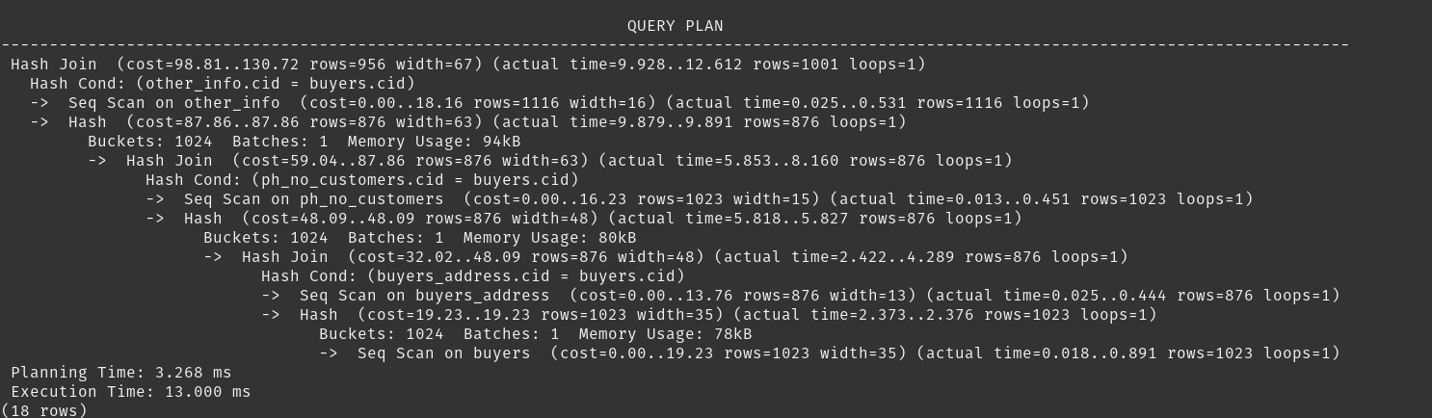

9. explain analyze select * from other_info natural join buyers_address natural join buyers natural join ph_no_customers;

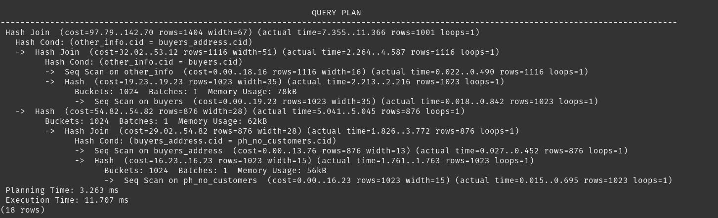

10. explain analyze select * from other_info natural join buyers_address natural join ph_no_customers natural join buyers;

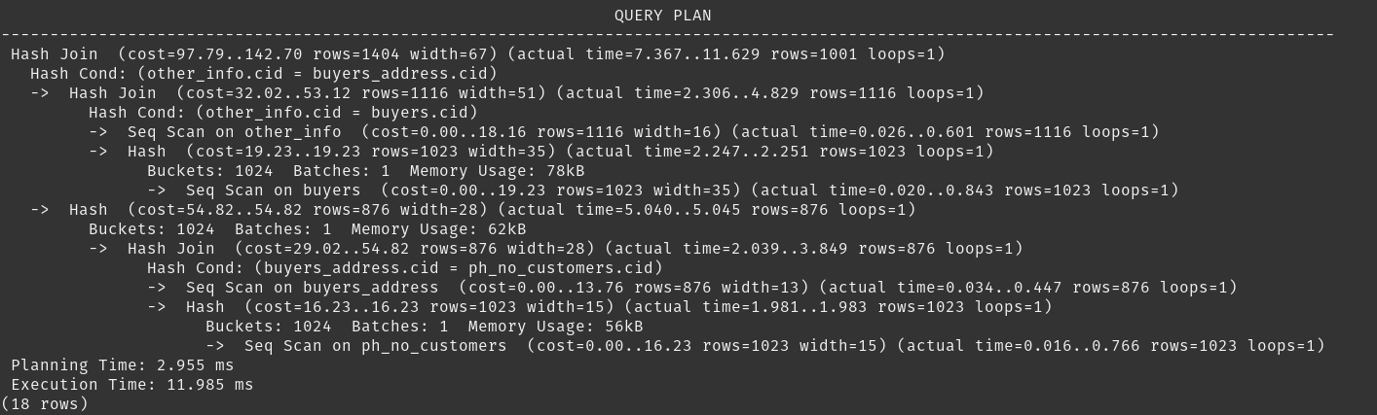

11. explain analyze select * from other_info natural join ph_no_customers natural join buyers natural join buyers_address;

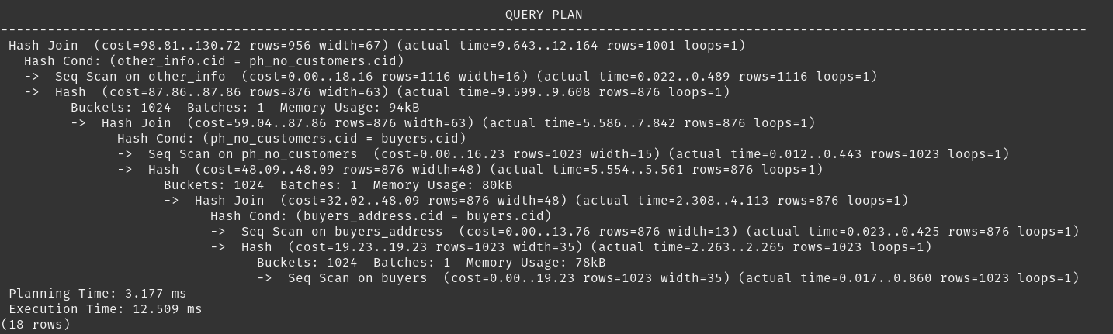

12. explain analyze select * from other_info natural join ph_no_customers natural join buyers_address natural join buyers;

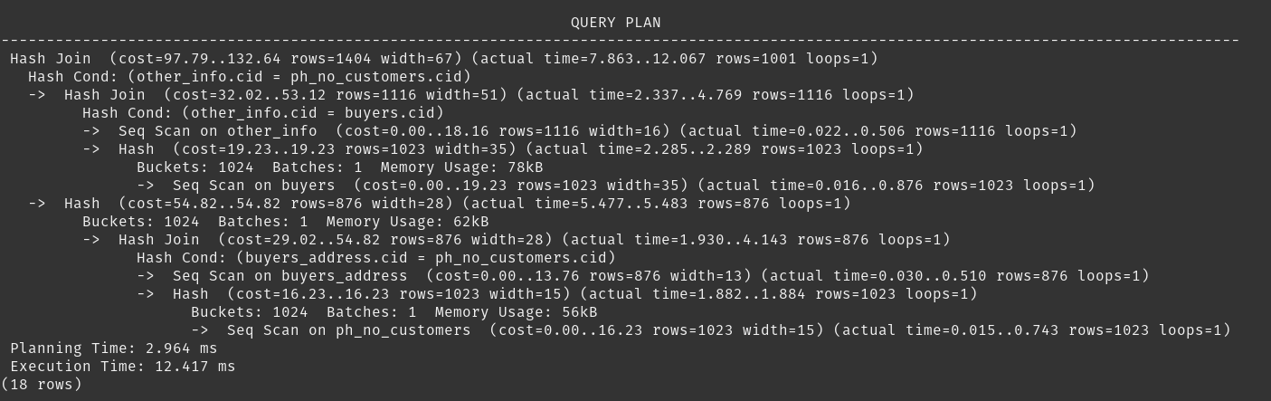

13. explain analyze select * from buyers_address natural join buyers natural join other_info natural join ph_no_customers;

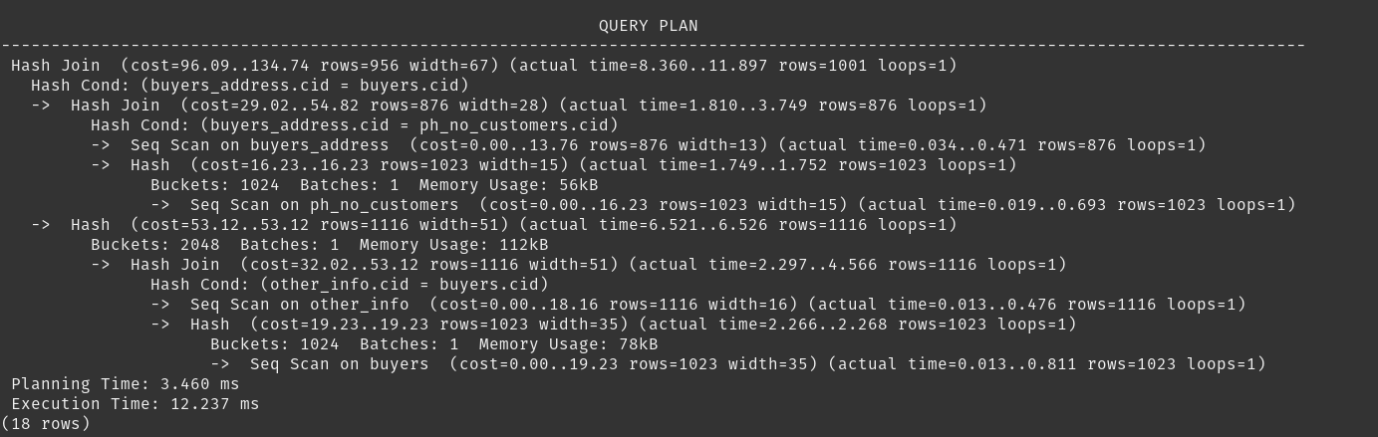

14. explain analyze select * from buyers_address natural join buyers natural join ph_no_customers natural join other_info;

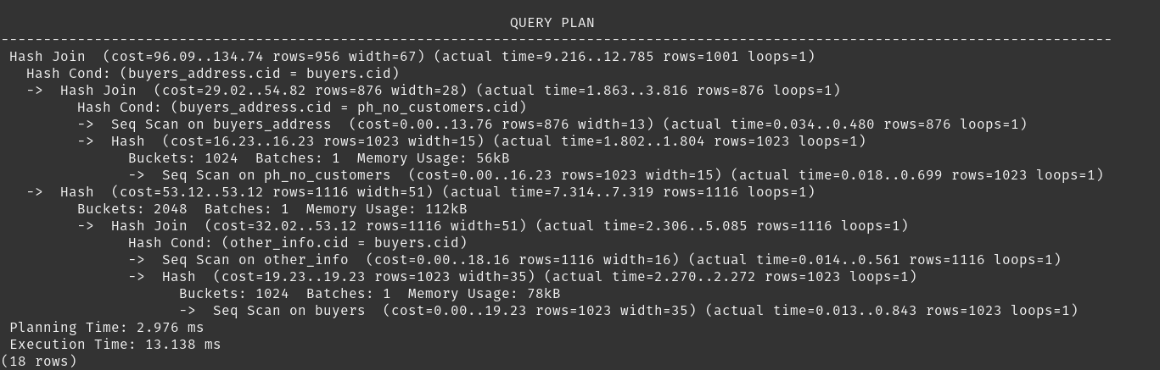

15. explain analyze select * from buyers_address natural join other_info natural join buyers natural join ph_no_customers;

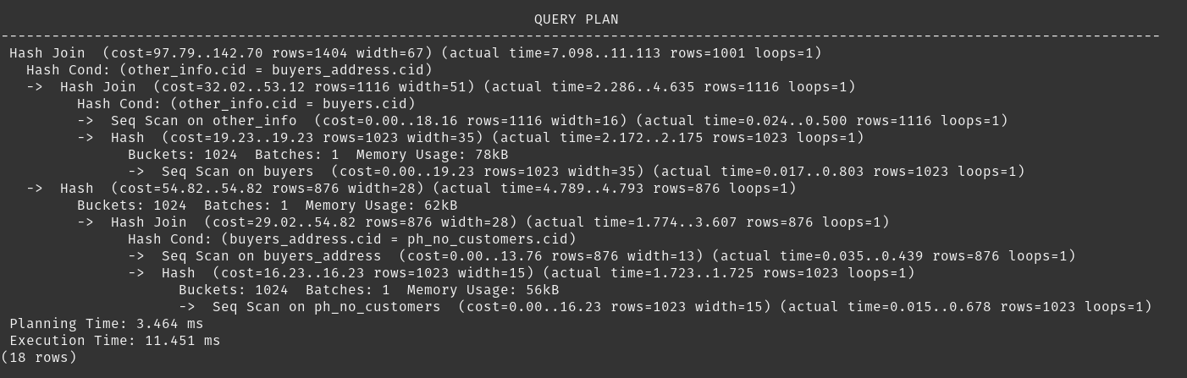

16. explain analyze select * from buyers_address natural join other_info natural join ph_no_customers natural join buyers;

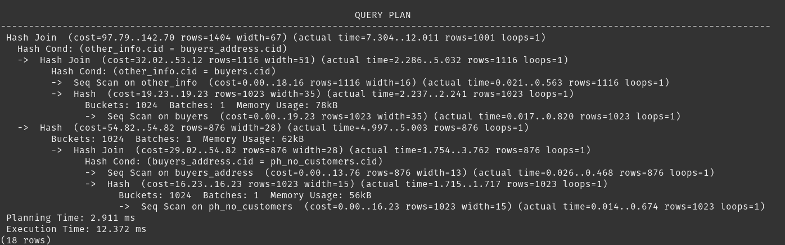

17. explain analyze select * from buyers_address natural join ph_no_customers natural join buyers natural join other_info;

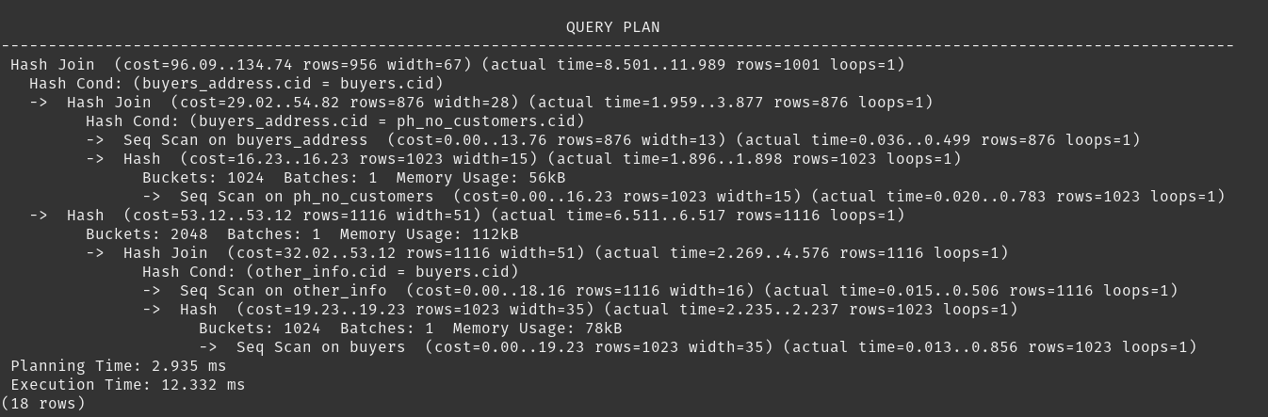

18. explain analyze select * from buyers_address natural join ph_no_customers natural join other_info natural join buyers;

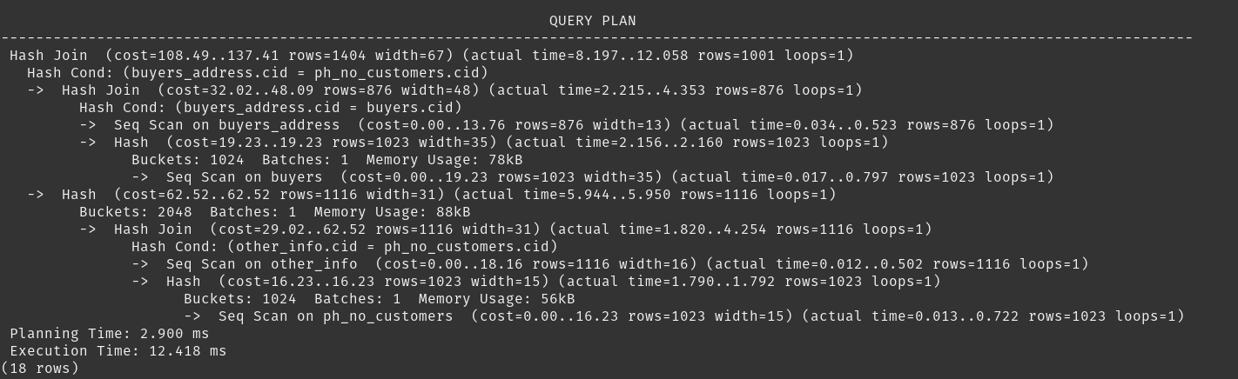

19. explain analyze select * from ph_no_customers natural join buyers natural join other_info natural join buyers_address;

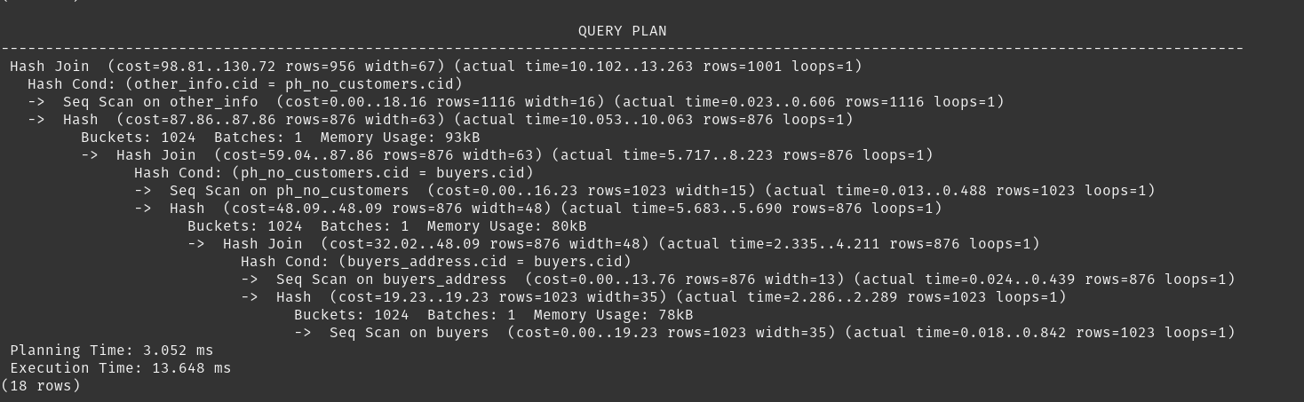

20. explain analyze select * from ph_no_customers natural join buyers natural join buyers_address natural join other_info;

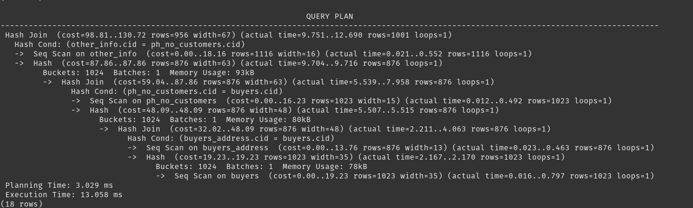

21. explain analyze select * from ph_no_customers natural join other_info natural join buyers natural join buyers_address;

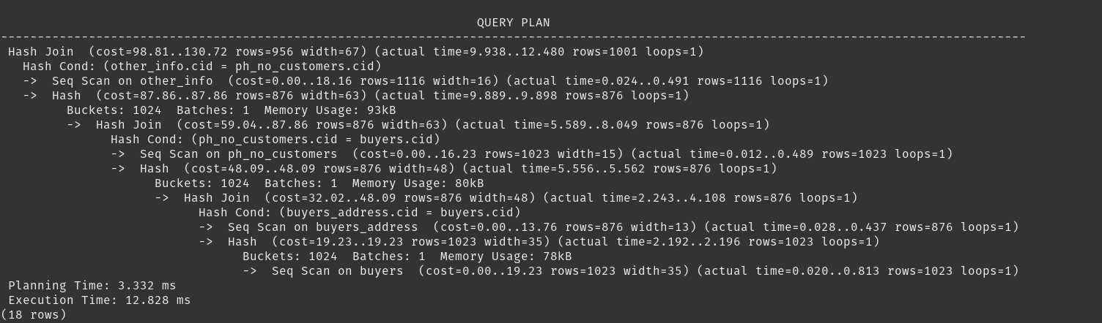

22. explain analyze select * from ph_no_customers natural join other_info natural join buyers_address natural join buyers;

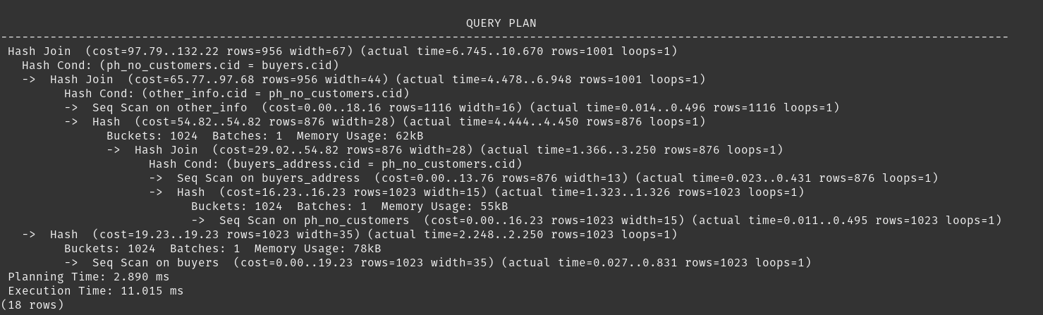

23. explain analyze select * from ph_no_customers natural join buyers_address natural join buyers natural join other_info;

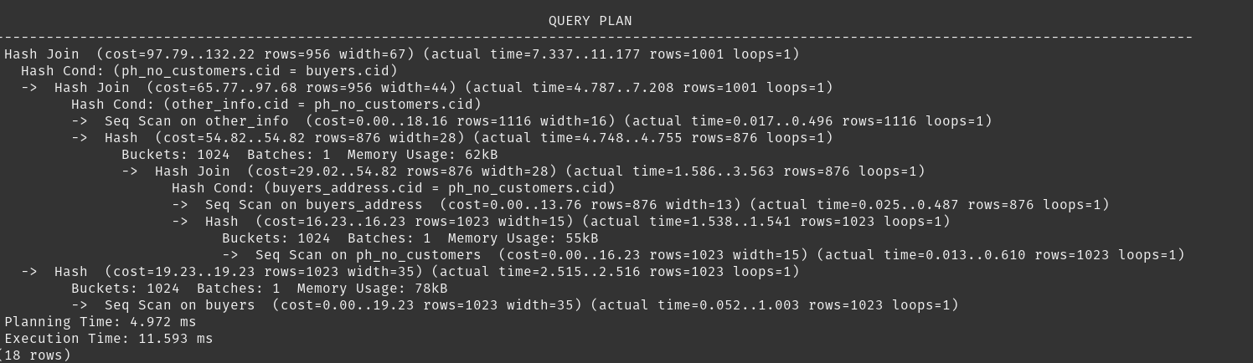

24. explain analyze select * from ph_no_customers natural join buyers_address natural join other_info natural join buyers;

